

Faculty of Engineering, Environment and Computing

7052CEM
Mobile Platforms and Application Development

My Auto Repair Shop

Individual Report

04/07/2023

Gudla Vishal Kumar Reddy
Id No:13929349

Table of Content
1. Objective 3
2. Targeted users 3
3. Features and functionalities 3
4. Details of data collected and Used.........................4
5. Screenshots of the Application 5

- Objective

The project involved a small group of five developers creating a mobile application, Auto Repair Shop, fulfilling a set of predefined requirements. To make the development process easier, we opted for Alpha Transform, a no-code/low-code mobile application development platform known for its user-friendly features and benefits. This approach allowed non-technical users to create mobile applications with minimal coding knowledge, making it accessible to a broader audience.

The objectives of the Auto Repair Shop application were to streamline and enhance the operations of an automotive repair and maintenance workshop. Key objectives included managing service requests, appointment scheduling, inventory management, workshop staff management, vehicle information management, service reminders, billing and invoicing, online payments and booking, real-time updates, feedback and reviews, and ensuring data security and compliance.

- Targeted users

The targeted users of the application were diverse and included vehicle owners, fleet managers, skilled mechanics, workshop managers, service advisors, auto parts suppliers, insurance companies, corporate clients, car dealerships, and other entities within the automotive industry. Furthermore, car dealerships, OEMs, vehicle rental companies, roadside assistance services, and other entities within the automotive industry may collaborate with auto workshops for various purposes. The application aims to cater to these targeted users, offering a seamless experience that enhances communication, efficiency, and service quality within the workshop environment.

- Features and functionalities

During the development process, we were given specific components and tasks to use in the application, including two or more pages, one hidden/unhidden button, one or more action buttons, one or more decision trees, and one or more data groups. To implement these components, we made use of various Alpha Transform commands and functionalities.Which are shown in the picture below:

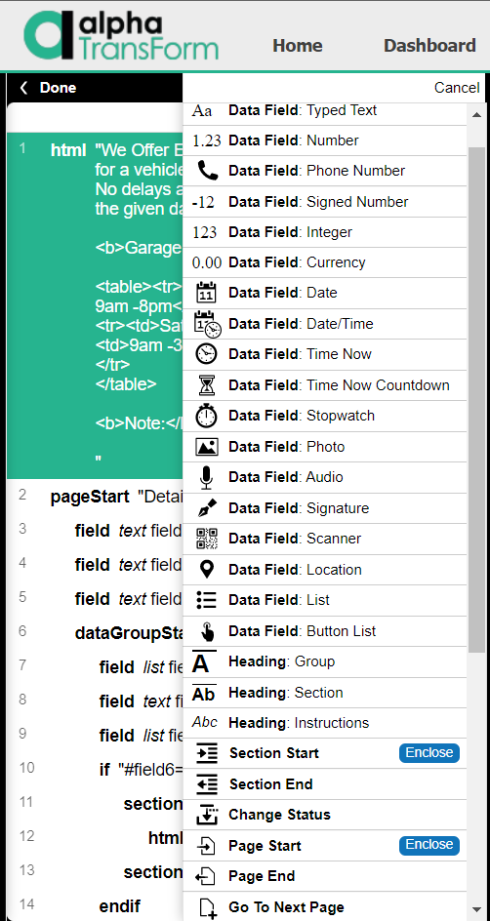

The Data Field command type encompasses various form field types such as Text, List, Location, Signature, Photo, Number/Integer, and more. Headings organize and describe form parts, including Group, Section, Instructions, Plain, Subheads, and Warning. HTML displays text with HTML characters escaped. Section Start/End structures and styles form sections. Page Start/End define multi-page forms. If, Else, Elseif, Endif allow conditional element display based on tests. Action Button executes TPL code on tap. These commands offer flexible and organized form creation, supporting various input and data options to enhance user experience and interaction.

Details of data collected and used
For data collection, we researched the basic services provided by local garages and found that pickup services were not widely available. Hence, we incorporated this feature in the Auto Repair Shop application to cater to customers in emergencies or those located far from the garage.To enhance the spare parts section of the application, we gathered data on interior and exterior car parts from reliable websites. This data helps us maintain a comprehensive list of available parts and allows customers to request parts not in stock for ordering.So, that I can know the parts which I can maintain in the spare parts section.

For the interior parts I used the data from the website:
https://mechanicalboost.com/car-interior-parts/

And for the exterior parts the website:
https://www.automotiveplastics.com/automotive-plastics-today/exterior/

This data is used in the Spare parts section of the application and customers can even contact us if they need any other part which are not available with us.So, that we can order that part and carry our work.

- Screenshots of the Application
